The Incorrigibles
Perspectives on Disability Visual Arts in the 20th and 21st Centuries.
A review by Pearl Findlay July 2017
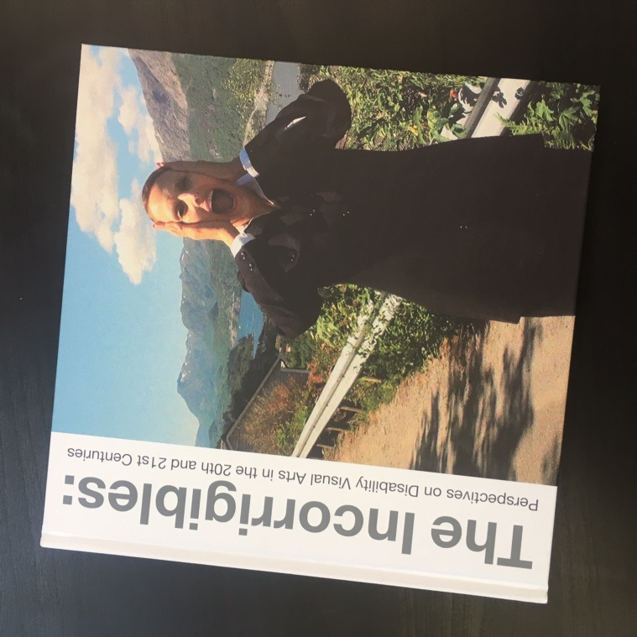
In 2015, DASH was awarded funding by Arts Council England and in partnership with mac Birmingham, to create a book, an encyclopaedia if you will, of the most pertinent and esteemed disabled artists in the UK. It published in 2016, sharing it's birthdate with the 40th anniversary of Shape Arts. As a trustee at DASH and as an emerging disabled artist, the development of this book was of interest to me.
‘The Incorrigibles’ Cover image by Anna Berndtson, Nations – Norway 1, Video Still, 2012

The definition of the term 'incorrigible' is boldly stated at the beginning; "(of a person or their behaviour) not to be changed or reformed." This definition acts as a necessary introduction to the book.
Adrian Plant and Tanya Raabe-Webber, two artists who identify as disabled, discuss just that. The decision to self-identify and the impact that has can be both problematic and beneficial on an artist's work, particularly in the mainstream art world. They introduce the motive of the book being both an enlightening tool and necessary celebration, against a place where disability arts is still largely discredited. They explain how Cultivate, a bespoke mentoring project for disabled visual artists, and acted as a foundation talking point and catalyst in the creation of this book. Most of the artist's featured in the book were part of such groups, and so it rings throughout the book as important reference points.
Craig Ashley's short essay discusses how the book came to fruition from the symposium Awkward Bastards. There is a clear reaction from the notable lack of presence from such a book and the disability arts lack of recognition in the mainstream arts world is frustrating. He gives a detailed account of political views:
"We felt there was a question around legitimacy that also needed to be framed as part of the conversation, to acknowledge the historical context of exclusion and subsequent civil rights action in Britain during the post-war period."
He touches on the issue around the legitimacy of the mainstream arts world, and discusses the positive movement that can be taken from the symposium, notably that the Arts Council cited diversity to be 'a key issue in relation to the programming and audiences, leadership and workforce of all our funded organisations.' from 2014. He references the Black Arts Movement as a means to illustrate a similar need for a revolution to push forward the Disability Arts Movement. Ashley gives an informative, honest yet optimistic hope for change, in which Awkward Bastards clearly encapsulated.
Tony Heaton begins his own essay by quoting Bill Bryson on the surprising figures of British Inventions and how that includes disability arts, as a unique springboard to an informative view of the Social Model of Disability. He gives a historical account of how the politics of disability has challenged local authorities, given access to the arts and built positive relationships that have led to the current form of disability arts.
The Incorrigibles are 14 selected visual artists discussing their practice. They were asked 6 questions that aimed to provide "inspiration and advice to the readers of this book" in which it most definitely delivers.
The sorts of questions posed were not in anyway assuming, and instead scoped an interesting and colourful portrait of them as individuals, as artists, and as disabled people, along with the difficult question around self-identifying as a disabled artist. The use of questions very much dictated their answers;
"What/who inspired you to want to become an artist"
"What were the main personal challenges you faced during your early career as an artist and what strategies did you develop?"
"As an established/respected artist can you reflect on your relationship to the so called 'mainstream' museum and art worlds?"
"In what ways has the existence of the 'Disability Art movement' helped or hindered your career development?"
"Tanya Raabe-Webber identified herself to be a disabled artist, borne out of the Disability Arts movement. How do you choose to define yourself as an artist and why?"
"What advice would you consider most vital to give an emerging Disabled Artist and why?"
Although many of the artists simply feel their destiny was to always be an artist, or that their education nurtured them into becoming an artist, many of the artists felt it grew from a form of rebellion against mainstream views imposed on them during their youth, which comes as no surprise to a disabled artist. This notion spurred self-led teachings of their chosen art form; in fact, disability led many of them to art. As David Hevey says, "Just when it couldn't get any more weird; it did: I got epilepsy. This was both the final and terrible end, and the enlightening beginning of the rest of my life."
Jon Adams is an esteemed artist specialising in abstract digital illustrations. When asked about identifying as a disabled art maker, he answers, "I am artist first and yes, I'm an autistic person".
Perhaps this view of self-identity aids the positive relationship he has with the arts sector in which he works.
"I have actively been chosen for projects because of my Autism/Asperger's... If you want to see work that is different, commission people to think differently, but also think differently about the way you commission and treat them...to be honest I've never registered that there is anything other than mainstream; I don't like using the word mainstream as it implies segregation... The work should speak for itself."
This I think is agreed from most art makers whether disabled or not, Bobby Baker makes the equally important point that rather her disability, she feared of being ousted at St Martins for being simply being a woman and not conforming to housewife ideals.
Juan delGado also echoes this point of view. Highlighting the ever-growing how the digital landscape gave him and other independent filmmakers the platform for real artistic success on a mainstream stage.
One of the highlights of the book is the contribution from Sue Austin. Sue Austin is a wheelchair user who uses herself as the subject in her work. Her work encapsulates the term 'disability arts', as her chosen images from 'Creating the Spectacle!' depict her 'Flying Free' through a coral reef in her wheelchair. This body of work, as she explains, I personally was delighted to see her included in this book. I wrote my dissertation on the disabling images the media portrays, I found her work to be the most notably? against the argument in my research. I found myself nodding in agreement when she states, "I feel a sense of recognition and shared identity with Disability Arts that acknowledges the complex realities of the disability experience."
These are just a few accounts of the importance of disability arts and the liberation of disability arts. "Disability Arts exists and I for one feel better and stronger in knowing this."
Statements like this by Heaton, are peppered throughout the book, shouting loud and proud about disability arts, and thereby creating a medium to talk openly about the history of disability arts, it's current position in difficult times, and encourages discussion and optimism for it's future.
The Incorrigibles offers viewpoints around political movements, and erased rich history, often overlooked by mainstream arts. It acts an empowering tool that any artist should be proud to have on their bookshelf to fully understand the complexities of an important genre of art.

