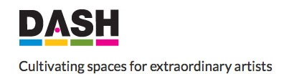

Gail Howard - g39:
Gail Howard is a co-director of Made in Roath, an arts organisation conceived in June 2009 by a small group of Roath based artists who share a love of their community.

Her commission at g39 was a curatorial residency, realised in July 2016.

does that include us? is a multi-artform programme of events presented by artists, facilitators and activists, some who identify as disabled and some who don’t.
For the first part of the season, 22 July – 25 August, you are invited to participate in social gatherings, performances, practical activities, conversations and debates. Through these activities we will find innovative and experimental ways to promote discussion around the subjects of access, inclusion, empathy and diversity within the arts and the wider community.
The second part of the season, 2 – 24 September, will be an exhibition of documentary material with an accompanying exhibition of the paintings of Sargy Mann.
does that include us? / yn cynnwys ni? is the culmination of a year-long period of curatorial mentoring offered by g39 to artist-curator Gail Howard, and forms part of the Tu Fewn project supported by DASH and Disablity Arts Cymru.

For further information on all of the individual events which formed the programme, please visit the website by clicking here: http://www.g39.org/cgi-bin/website.cgi?place=exhibitions&id=5012

Background of Tu Fewn:
Tu Fewn is an exciting new development opportunity for arts organisations in Wales to commission new high quality work by Disabled visual artists from across the UK and Internationally. Working in partnership with Disability Arts Cymru with funding from Arts Council Wales.

The aims of Tu Fewn are:
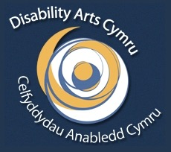
• To increase the number of Disabled visual artists :
• Exhibiting in mainstream galleries in Wales
• Developing Curatorial skills with Mainstream galleries in Wales
• Working with Arts Organisations in Wales
• To change working practices of galleries and arts organisations through a practical partnership and network
• To increase the number of Disabled people as an arts audience.
